# Jaccard Coefficient Calculations

The table shows the pathological test results for three individuals.

| **Name** | **Gender** | **Fever** | **Cough** | **Test-1** | **Test-2** | **Test-3** | **Test-4** |
| --- | --- | --- | --- | --- | --- | --- | --- |
| Jack | M | Y | N | P | N | N | A |
| Mary | F | Y | N | P | A | P | N |
| Jim | M | Y | P | N | N | N | A |

Calculate Jaccard coefficient for the following pairs:

* (Jack, Mary)
* (Jack, Jim)
* (Jim, Mary)

The Jaccard similarity coefficient compares members for 2 sets to see which members are shared and which are distinct. It is a measure of percentage and the higher the number the more similar the two populations.

Jaccard Index = (the number in both sets) / (the number in either set) * 100

The same formula in notation is (Statistics How To, 2016):

J(X,Y) = |X∩Y| / |X∪Y|

To calculate the Jaccard coefficient, we first convert the asymmetric variables to binary values and re-write the table. Since Gender is a symmetric variable (that is, male, female have the same weight), it is not converted.

So let Y & P = 1; N & A = 0

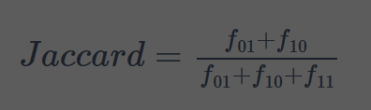

* (Jack, Mary)

F01 = 1

F10 = 0

F11 = 2

(1/3)*100 = **33.33%**

* (Jack, Jim)

F01 = 1

F10 = 1

F11 = 1

(⅔)*100 = **66.67%**

* (Jim, Mary)

F01 = 2

F10 = 1

F11 = 1

(¾)*100= **75%**

**References**

Statistics How To. (2016). Jaccard Index / Similarity Coefficient. Statistics How To. Available at: <https://www.statisticshowto.com/jaccard-index/> [Accessed 25 January 2025].